DSDV
USING
BORDER GATEWAY PROTOCOL

INSTRUCTOR: Prof Vicky Hsu

Santhosh Kumar Kotapally A1370
Mahesh Kumar Donthula A1371

INDEX
CONTENTS Page No
ABSTRACT 5
1. INTRODUCTION 6
1.1 Introduction 6
1.2 Scope and Objective of the project 7
1.3 Existing System 8
1.4 Proposed System 8

2. PROJECT DESCRIPTION 9
2.1 Internet Architecture 9
2.2 Routing in Internet 10
2.2.1 Intra Domain Routing 11
2.2.2 Inter Domain Routing 11
2.3 Border Gateway Protocol 12
2.4 Modeling BGP 13
2.4.1 C-BGP:A BGP Routing Solver 13
2.5 Destination Sequenced Distance Vector 14
2.5.1 Selection of Route 15
2.5.2 Routing Information 16
2.6 Module Description 17
2.6.1 Finding the Feasible Path 17
2.6.1.2 Bellman-Ford Algorithm 17
2.6.2 Construction of Routing Table 18

3. FEASIBILITY ANALYSIS 19
3.1 Technical Feasibility 19
3.2 Economical Feasibility 20
3.3 Operational Feasibility 21

4. SYSTEM REQUIREMENTS 22
4.1 Hardware Requirements 22
4.2 Software Requirements 22
4.3 Functional Requirements 22
4.4 External Interface Requirements 23
4.4.1 User Interface 23
4.4.2 Software Interface 23
4.4.3 Hardware Interface 23
4.5 Performance Requirements 24
4.6 Software Requirement Specification 25
4.6.1 Purpose 25
4.6.2 Scope 25
4.6.3 Definition 25

5. SYSTEM DESIGN 26
5.1 UML Diagrams 26
5.1.1 Class Diagram 26
5.1.2 Sequence Diagram 27
5.1.3 Collaboration Diagram 28
5.1.4 Activity Diagram 29

6. IMPLEMENTATION 30
6.1 Screen Shots 30
6.1.1 Main Screen 30
6.1.2 Input Screen 31
6.1.3 Screen Showing The Nodes 32
6.1.4 Node Position After Some Time 33
6.1.5 Screen Showing Feasible Path 34
6.1.6 Screen Non Existence of Path 35
6.1.7 Screen Showing The Routing Table 36
6.1.8Screen Showing Improper Source or Destination 37
6.1.9 Screen Showing Improper Source or Destination 38

7. TESTING 39
7.1 Introduction 39
7.2 Levels Of Testing 39
7.2.1 Function Testing 40
7.2.2 Structural Testing 40
7.3 Testing Process 40
7.3.1 Test Plan 41
7.3.2 Test Case Specification 41
7.4 Test Case Execution and Analysis 41
7.4.1 Unit Testing 41
7.4.2 Integration Testing 42 7.4.3 System Testing 42 7.5 Test Cases 43

8. CONCLUSION 45

BIBLIOGRAPHY
LIST OF FIGURES
LIST OF TABLES

ABSTRACT

The project mainly describes the model and the tool that we use throughout the whole thesis to simulate the interdomain routing system. Such a tool is needed to better understand the current Internet infrastructure and its routing protocol, BGP. DSDV Using Border Gateway Protocol is an application oriented simulation. On one side, understanding BGP is required for network operators that want to better manage their network and prepare it to support new Internet-based services. On the other side, a good understanding of BGP is also required for researchers that want to characterize the behavior of BGP in the global Internet.

The motivation behind the development of this tool is to make possible “playing” with BGP for the purpose of evaluating the existing Internet infrastructure as well as to design the future traffic engineering mechanisms. The tool focuses on the selection of routes by BGP, not on a model of the convergence of BGP.The selection of routes is done by the routing protocol DSDV (Destination Sequenced Distance Vector).The DSDV protocol implements the shortest path first policy and selects the more feasible path among the number of available paths for communication in the network. The thesis can be implemented in the complex internet architecture to enhance the overall performance of the network in terms of
Network size and the quality of services.

1 INTRODUCTION
1.1 INTRODUCTION
Initially developed as a network that connects a small number of research networks, the Internet has become a world-wide data network that is used for mission critical applications such as Voice over IP (VoIP) or Virtual Private Networks (VPNs). Supporting such applications across the global Internet implies several important challenges. The first challenge is the size of the Internet. The Internet is a large decentralized network that already connected about 350 million hosts in June 2005. Furthermore, these hosts are organized in about 21,000 distinct domains, a domain corresponding roughly to a company, an Internet Service Provider (ISP) or a campus network. All these domains are interconnected to form the global Internet.

Over this large interconnection of networks, ISPs run two different families of routing protocols. Intradomain routing protocols are used within the ISP while an Interdomain routing protocol is used across the ISP boundaries. The second challenge is the evolution of the Internet in terms of quality of service requirements. The initial research Internet was designed with a best effort service in mind where connectivity was the most important issue.

Destination Sequenced Distance Vector Using Border Gateway Protocol mainly deals with interdomain routing and enhances the performance of the Network in terms of both Internet size and Quality of the services it provides. BGP is a de facto standard routing protocol. It also deals with Traffic Engineering. Traffic Engineering covers the evaluation and the improvement of the performance of operational IP networks.

1.2 SCOPE AND OBJECTIVES

- BGP contains a well-understood and widely-deployed mechanism for data distribution.
- DSDV Using Border Gateway Protocol can be implemented in the existing and emerging topologies of network.
- Complex issues related to networks in terms of quality and size can be better dealt with BGP.
- The BGP routing solver must not be limited to a single domain. Since we want to be able to study both the routes that a particular domain has selected to reach external domains as well as routes that other domains will use to reach this particular domain.
- The BGP routing solver must be deterministic. That means that its outcome must only depend on the initial configuration of the simulated network as well as on the advertised routes.
- Main objective of our project is to reduce the cost incurred in data communication and to provide a reliable network.
- The routing solver must be able to handle very large topologies with a size of the same magnitude as the Internet, i.e. composed of thousands of Ass themselves containing hundreds of routers.

1.3 EXISTING SYSTEM

Routing in each level of the Internet is performed by a different routing protocol. The route selection performed relies on the optimization of a single metric in existing routing protocols. The organization of the current Internet infrastructure in two levels has an impact on the efficiency of interdomain Traffic Engineering. In large network topologies the mobility of nodes in a given topology is limited. It is a difficult task to update the routing information of the nodes dynamically.

1.4 PROPOSED SYSTEM

The rationale behind the design of BGP was to provide reachability among domains and the ability for any domain to enforce its own routing policies. Limits the large scale selection of inter domain paths .The Dynamic Nodes routing information is maintained in Routing Table which helps in finding details of a Node at a particular instant of time. The impact of efficiency of interdomain Traffic Engineering is minimized in the proposed system.

2 PROJECT DESCRIPTION

2.1 INTERNET ARCHITECTURE

The Internet is a network composed of a huge collection of smaller networks, themselves containing a myriad of end systems and routers. The end systems are hosts such as personal computers or servers. They are usually the sources or sinks of data packets transiting on a network. The routers are the intermediate systems that intervene in the transport of data from an end system to another. Since the many networks that form the Internet are operated by a lot of independent institutions, the Internet is organized in two levels.

The first level is the Intradomain level. A set of routers that is under a single administrative authority form a domain. A domain can be the network of a company, an Internet Service Provider (ISP) or a single campus network. An example ISP is represented in Fig. 3.1.1. The routers of a domain are usually interconnected using multiple Synchronous Optical Networking links (SONET/SDH) and/or Ethernet. We distinguish the core links that interconnect the routers within the domain and the edge links that cross the domain boundaries.

The second level of the Internet is the Interdomain level. It designates the interconnections between the different domains. In the Internet, a domain is also called an Autonomous System (AS). Most ASes are uniquely identified by an Autonomous System Number (ASN). Note that all domains need not to have a public ASN. This is usually the case for small to medium size university or corporate campus networks that buy connectivity from a single ISP.
FIG 2.1.1 Topology of an ISP Network

2.2 ROUTING IN INTERNET

To be uniquely identified in the Internet, each end system and router receives one or more Internet Protocol (IP) addresses. In the current version of the IP protocol (IPv4), an IP address is a 32bits integer number. It is usually represented in the dotted format A.B.C.D. An example of IP address is 66.249.93.99. Each AS in the Internet is often being allocated blocks of contiguous IP addresses that they can use for their own network or delegate to their customers. The physical topology of the Internet defines the feasible paths that can be used to cross the network. The role of routing consists in determining for a given Internet device the path to be used to reach a destination IP address. In order to determine these paths, all the routers in the Internet usually exchange information about the network topology. These exchanges are supported by a routing protocol.

2.2.1 INTRADOMAIN ROUTING

In the Internet, routing is handled by two distinct protocols with different objectives. An intradomain routing protocol is used inside each domain and a single interdomain routing protocol is used between domains. There are three main reasons for this schism. The first one is the need for scalability. An Intradomain routing protocol usually has a very detailed knowledge of the whole domain topology. It handles routes towards any destination within the domain. The objective of the Intradomain routing is to find the shortest paths according to a selected metric assigned by the network administrator.

2.2.2 INTERDOMAIN ROUTING

To the contrary, an interdomain routing protocol has a limited view of the Internet topology, restricted to the interconnection between domains. An interdomain routing protocol also handles routes towards large aggregates of IP addresses. This avoids having to handle routes towards any destination. The second reason for having two distinct routing protocols is the Independence of domains. Each domain is allowed to setup its Intradomain routing in an independent manner. Each domain is also allowed to perform policy routing. In order to learn routes towards destination located outside their own domain, the routers run the Border Gateway Protocol (BGP). BGP is the de facto standard routing protocol for the selection of the interdomain paths.

FIG 2.2.1 Internal and External BGP sessions.

2.3 BORDER GATEWAY PROTOCOL (BGP)

In this section, we describe the model and the tool that we use throughout the whole thesis to simulate the interdomain routing system. Such a tool is needed to better understand the current Internet infrastructure and its routing protocol, BGP. The tool focuses on the selection of routes by BGP, not on a model of the convergence of BGP. Reproducing the behavior of BGP is a challenging problem. In this chapter, we will explain why this is a difficult task.

The Internet is composed of an interconnection of hundreds of thousands of routers running BGP. Since the real Internet now supports critical applications, it is not possible to run large experiments or to deploy modified versions of BGP on the production routers. Due to the number of routers in the Internet, it is also not possible to reproduce the behavior of such a large network on genuine routers in a lab. A natural first step is thus to turn to simulations. However, building an efficient simulation model of BGP is a difficult task since it poses serious scalability constraints. In this chapter, we describe the hypothesis we take and their impact on the efficiency of the simulator.

2.4 MODELING BGP

Reproducing the behavior of BGP in a large topology with thousands of routers poses serious scalability constraints. Indeed, the BGP decision process is complex by nature because of its rules which define different sometimes contradictory orderings on the routes. Another difficulty comes from the distributed nature of BGP. The BGP decisions are taken in a distributed manner by the BGP routers, without explicit concentration. Though, a single local decision can affect the information available to all the other routers. There is therefore no easy shortcut in simulating BGP as it is the case for a link state protocol like OSPF where an enhanced Dijkstra algorithm can be used as a satisfactory model. The most efficient and straightforward method to simulate BGP is to build a realistic implementation of the decision and filtering processes and simulate the propagation of messages.

2.4.1 C-BGP: A BGP ROUTING SOLVER

In this section, we describe our approach to build a BGP routing solver meeting the requirements and the hypothesis that are taken in order to make it efficient. Our implementation of this routing solver is called CBGP. It is open source and publicly available. There are currently two main approaches to computing the BGP routes known by a router. The first one consists in resolving the dependencies between the routing decisions taken by the different routers in a distributed manner. Its main limitations are that it leads to a very specialized
model. Then, we do not model various timers that are used by BGP in order to minimize BGP a message churns.
Two timers are concerned. First, the Minimum Route Advertisement Interval (MRAI) timer is used to prevent a router to send to a neighbor too frequent updates for the same destination prefix. The second timer is used by a technique called Route Flap Dampening which will avoid too frequent updates received from neighbor routers for the same prefix to be taken into account by the decision process. We do not model these timers since we do not care about routes that are flapping. This is reasonable since the large majority of Internet routes are stable over time.

Finally, we use a steady state model of the IGP protocol to compute the Intradomain routes without exchanging messages. A model of the IGP protocol is needed to compute the paths between BGP routers for instance. Of BGP even if it might be slightly more efficient and that it is limited to a single domain. The other approach is to reproduce the propagation of BGP messages between the routers and the route selection performed by each router. This is the approach used in CBGP.

2.5 DESTINATION SEQUENCED DISTANCE VECTOR (DSDV)

The Destination-Sequenced Distance-Vector (DSDV) is a table-driven routing scheme for wireless networks based on the idea of the classical Bellman-Ford Routing Algorithm with certain improvements. DSDV was one of the early algorithms available. It is quite suitable for creating ad hoc networks with small number of nodes. Since no formal specification of this algorithm is present there is no commercial implementation of this algorithm. Many improved forms of this algorithm have been suggested.

Every mobile station maintains a routing table that lists all available destinations, the number of hops to reach the destination and the sequence number assigned by the destination node. The sequence number is used to distinguish stale routes from new ones and thus avoid the formation of loops. The stations periodically transmit their routing tables to their immediate neighbors. A station also transmits its routing table if a significant change has occurred in its table from the last update sent. So, the update is both time-driven and event-driven.

2.5.1 SELECTION OF ROUTE

If a router receives new information, then it uses the latest sequence number. If the sequence number is the same as the one already in the table, the route with the better metric is used. Stale entries are those entries that have not been updated for a while. Such entries as well as the routes using those nodes as next hops are deleted.

A full dump sends the full routing table to the neighbors and could span many packets whereas in an incremental update only those entries from the routing table are sent that has a metric change since the last update and it must fit in a packet. When the network is relatively stable, incremental updates are sent to avoid extra traffic and full dump are relatively infrequent. In a fast-changing network, incremental packets can grow big so full dumps will be more frequent.

Each route update packet, in addition to the routing table information, also contains a unique sequence number assigned by the transmitter. The route labeled with the highest (i.e. most recent) sequence number is used. If two routes have the same sequence number then the route with the best metric (i.e. shortest route) is used.

2.5.2 ROUTING INFORMATION

Destination Sequenced Distance Vector provides the routing information of the individual nodes in the network dynamically. The Routing Information is mainly described in the form of a table which constitutes the attributes of a node like Destination Node, Next Hop, Number of Hops or Metric and Sequence number of the node.

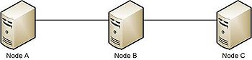
Fig 2.5.2.1 NODES IN A NETWORK
For example the routing table of Node A in the above network is

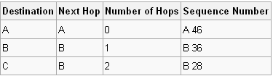
FIG 2.5.2.2 ROUTING TABLE OF NODE A

The Routing Table plays a key role in DSDV and holds the routing information of the nodes according to the mobility and current position of the nodes.

2.6 MODULE DESCRIPTION
The whole thesis can be divided into the two main modules. The Modules are:
1. Finding the feasible path between a source and destination node.
2. Constructing the Routing Table of a node dynamically.

2.6.1 FINDING THE FEASIBLE PATH BETWEEN A SOURCE AND DESTINATION NODE

This module deals with the finding the feasible path from a given source to the destination. It first searches for the available paths from a source to destination and selects the shortest path from the available number of paths for communication. Bellman-Ford algorithm is used to compute the shortest path in the network.

2.6.1.1 Bellman-Ford Algorithm

Bellman–Ford is in its basic structure very similar to Dijkstra's algorithm, but instead of greedily selecting the minimum-weight node not yet processed to relax, it simply relaxes all the edges, and does this |V| − 1 times, where |V| is the number of vertices in the graph. The repetitions allow minimum distances to accurately propagate throughout the graph, since, in the absence of negative cycles, the shortest path can only visit each node at most once. Unlike the greedy approach, which depends on certain structural assumptions derived from positive weights, this straightforward approach extends to the general case.

It consists of the following steps:
- Each node calculates the distances between itself and all other nodes within the AS and stores this information as a table.
- Each node sends its table to all neighboring nodes.
- When a node receives distance tables from its neighbors, it calculates the shortest routes to all other nodes and updates its own table to reflect any changes.

2.6.2 CONSTRUCTION OF ROUTING TABLE

This module deals with the construction of routing table for each and every node in the network. One can select any node to see the routing information of that particular node. If a node is selected at random say H1, then H1 acts as a source node and the routing table is shown for all the nodes as destination nodes from the source node.

3. FEASIBILITY ANALYSIS

All projects are feasible, given unlimited resources and infinite time. But the development of software is plagued by the scarcity of resources and difficult delivery rates. It is both necessary and prudent to evaluate the feasibility of a project at the earliest possible time. Three key considerations are involved in the feasibility analysis.

Primarily whether a project that was initiated by somebody has to be considered for further development or not will be decided through preliminary investigation. As this investigation, feasibility analysis of the project is conducted. When the outcome of this feasibility analysis is fine, then request for the project is approved. This study will be done in these three areas: operational, technical and financial. Let us consider each area in brief.

3.1 TECHNICAL FEASIBILITY
Technical feasibility centers on the existing computer system (hardware, software, etc.,) and to what extent it can support the proposed addition. If the budget is a serious constraint, then the month is judged not feasible. This test focuses on the feasibility of technical environment required for the development and implementation of the project. First we have to verify whether the necessary technology exists or can be acquired to undertake the project. If any technical shortcomings are noted, the project is not feasible. If such technology exists, we’ve to check whether that technical equipment can handle the data required to

use the proposed system. If the proposed project involves networking, we’ve to examine whether the proposed system provides adequate response to the requests irrespective of the location and users. Also, the technical guarantees of accuracy, reliability, ease of access, and data security should be considered and the expandability of the project is to be tested.
This issue considers many things including necessary technology exists or not for suggestion system and also finds that the proposed equipment have the technical capacity to hold the data required to use the new system or not. In present system WINDOWS 98/XP/2000, Jdk1.4 was already installed and it also has the required hardware specifications. So it is technically feasible.
3.2 ECONOMICAL FEASIBILITY
As part of this, the costs and benefits associated with the proposed system are compared and the project is economically feasible only if tangible or imaginable benefits overweight costs.
The project can be done on PC with the hard disk. A well-done feasibility study is firm to avoid common mistakes often made in the system.
- Failure to clearly specify problems and objectives
- Estimate error.
- The hardware approaches
  - The cost to conduct a full systems investigation
  - The cost of h/w & s/w for the class of application being considered
  - The development cost
  - The cost of maintenance

3.3 OPERATIONAL FEASIBILITY
People are inherently resistant to change, and computers have been known to facilitate change. It is understandable that the introduction of a candidate system requires special effort to educate, sell, and train the staff on new ways of conducting business. There is sufficient support for the project from the Organization. The proposed system is acceptable to the users. So the proposed system is operationally feasible.

4. SYSTEM REQUIREMENTS

4.1 HARDWARE REQUIREMENTS:

COMPONENTS REQUIREMENTS
Processor : PENTIUM III or Later
Primary Memory (RAM) : 256 MB
Secondary Memory (Hard disk) : 1GB Free Hard Disk space

4.2 SOFTWARE REQUIREMENTS:
Operating System : Operating System which supports JVM

Programming Language : JAVA

UML Diagrams : Rational Rose 2002

4.3 FUNCTIONAL REQUIREMENTS

Functional requirements specify which outputs should be produced from the given inputs. They describe the relationship between the input and output of the system, for each functional requirement a detailed description of all data inputs and their source and the range of valid inputs must be specified. All the operations to be performed on the input data to obtain the output should be specified.

4.4 EXTERNAL INTERFACE REQUIREMENTS

4.4.1 User Interface

Here user interface is developed using Java swings and applets using which we can design and develop the pages which are attractive and dynamic. It is also very easy to navigate from one place to another place. We put lot of efforts to make the user interface attractive and process the data which is fed by the user.

4.4.2 Software Interfaces

This interface requirements should specify the inter face with other. Software which the system will use or which will use the system, this includes the interface with the operating system and other applications. The message content and format of each interface should be given.

4.4.3 Hardware Interfaces

Hardware interface is very important to the documentation. If the software is execute on existing hardware or on the pre-determined hardware, all the characteristics of the hardware, including memory restrictions, should be specified. In addition, the current use and load characteristics of the hardware should be given.

4.5 PERFORMANCE REQIREMENTS

All the requirements relating to the performance characteristics of the system must be clearly specified. There are two types of performance requirements – static and dynamic.
Static Requirements are those that do not impose constraint on the execution characteristics of the system. These include requirements like the number of terminals to be supported, and number simultaneous users to be supported, number of files, and their sizes that the system has to process. These are also called capacity of the system.

Dynamic requirements specify constraints on execution behaviour of the system. These typically include response time and throughput constraints on the system.

The processing speed, respective resource consumption throughput and efficiency measure performance. For achieving good performance few requirements like reducing code, less use of controls, minimum involvement of repeated data etc., are to be followed. Each real-time system, software what provides required function but does not conform to performance of software requirements is acceptable. These requirements are used to test run time performance of software with the context of an integrated system.

4.6 SOFTWARE REQUIREMENT SPECIFICATION

DSDV Using Border Gateway Protocol is an application oriented simulation of a network using the Destination Sequenced Distance Vector Routing protocol.

4.6.1 Purpose

The purpose of this document is to describe all external requirements for the DSDV Using Border Gateway Protocol. It also describes the interfaces for the system

    - Scope

This document describes the requirements of the system. It is meant for use by the developers, and will also be the basis for validating the final system. Any changes made to the requirements in the future will have to go through a formal change approval process. The developer is responsible for asking for clarifications. When necessary and will not make any alterations without the permission of client.

4.6.3 Definition

DSDV Using Border Gateway Protocol is an application oriented simulation that can be used in complex or large network topologies to fulfill the requirements of a wireless network.

5 SYSTEM DESIGN

5.1 UML DIAGRAMS

5.1.1 CLASS DIAGRAM

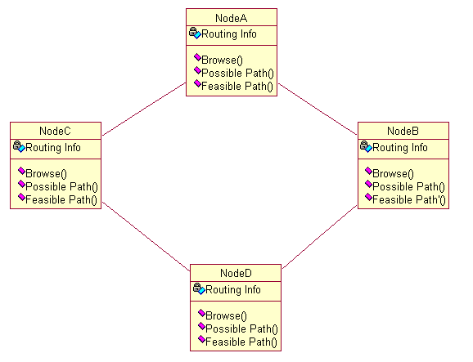

FIG 5.1.1

5.1.2 SEQUENCE DIAGRAM

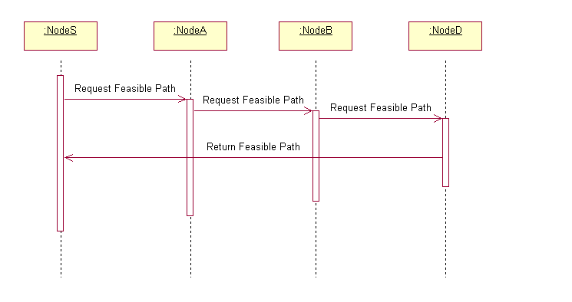
FIG 5.1.2

5.1.3 COLLABORATION DIAGRAM

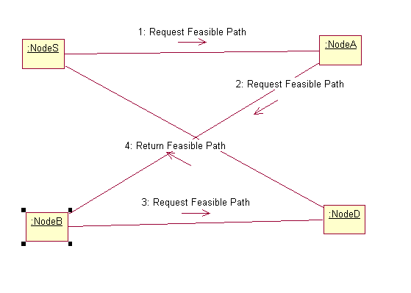

FIG 5.1.3

5.1.4 ACTIVITY DIAGRAM

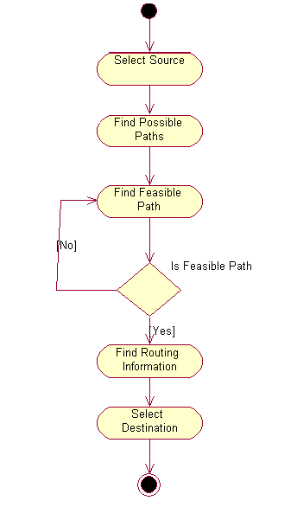

FIG 5.4.1

6. IMPLEMENTATION
6.1 SCREEN SHOTS

6.1.1 MAIN SCREEN

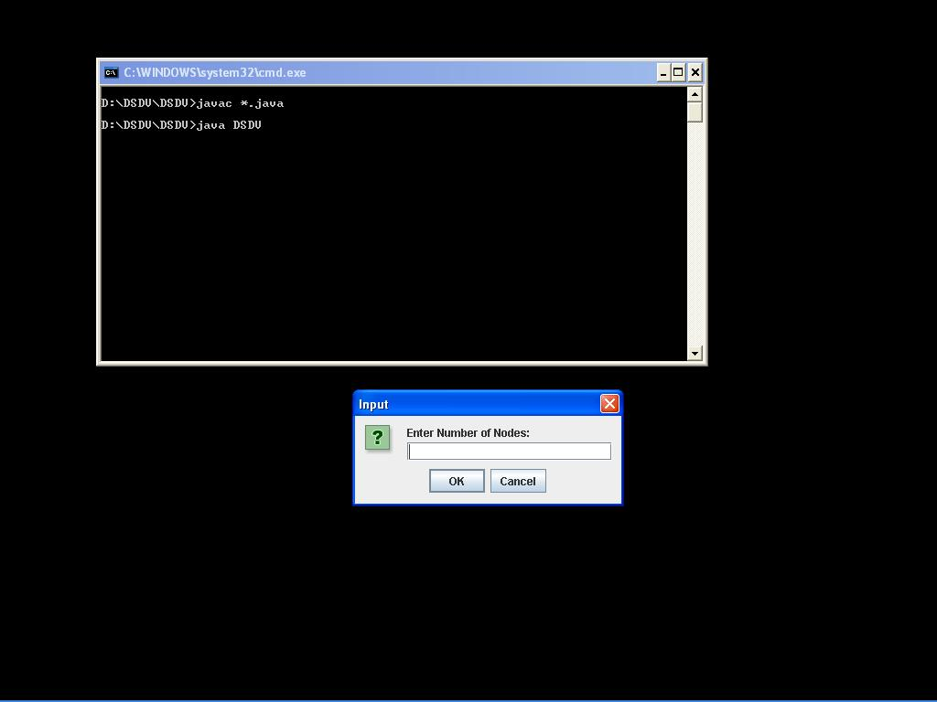
FIG 6.1.1 MAIN SCREEN

6.1.2 INPUT SCREEN

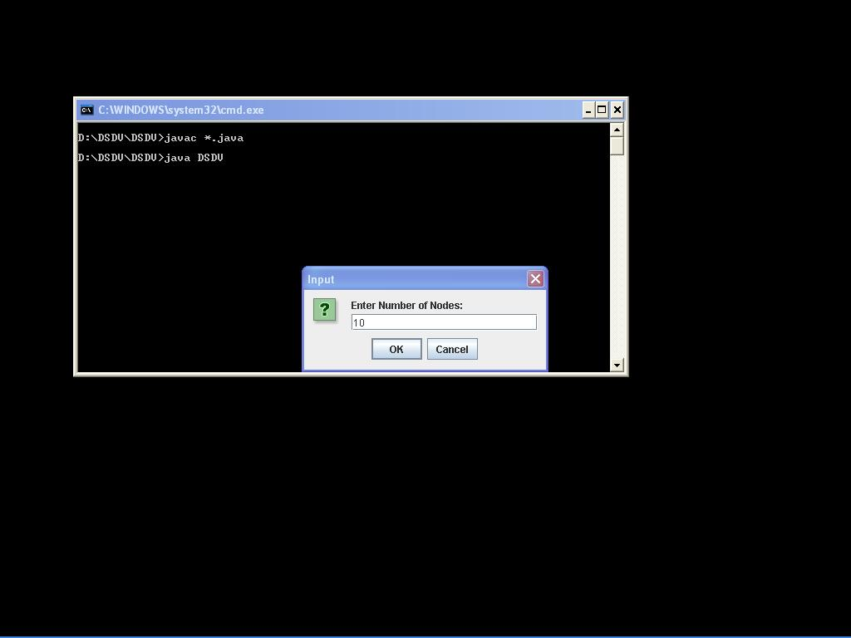
FIG 6.1.2 INPUT SCREEN

6.1.3 SCREEN SHOWING THE NODES

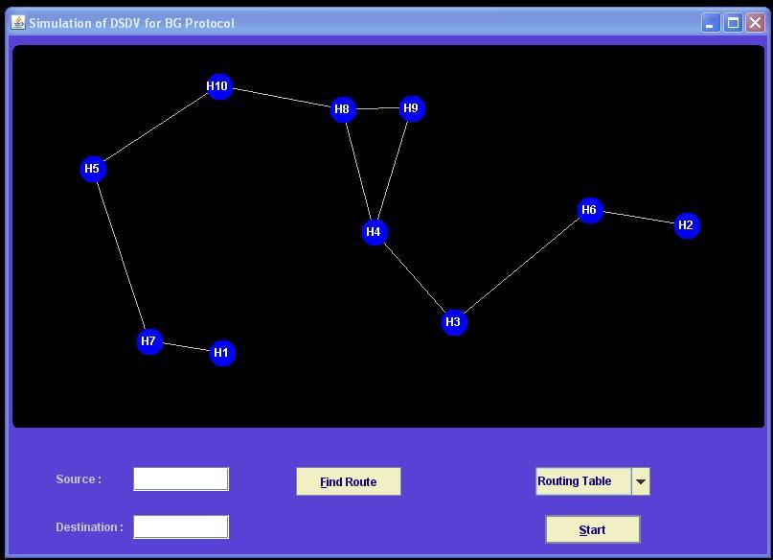
FIG 6.1.3 SCREEN SHOWING THE NODES

6.1.4 POSITION OF NODES AFTER SOMETIME

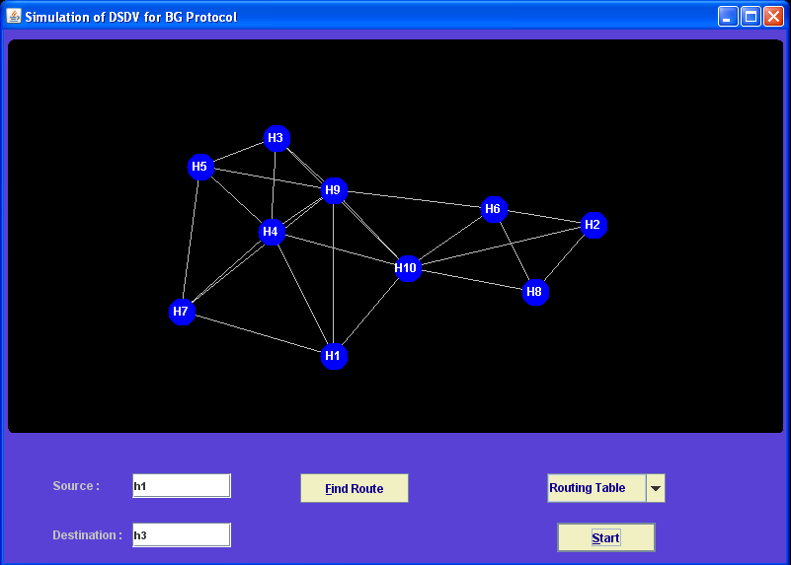
FIG 6.1.4 POSITION OF NODES AFTER SOMETIME

6.1.5 SCREEN SHOWING THE FEASIBLE PATH

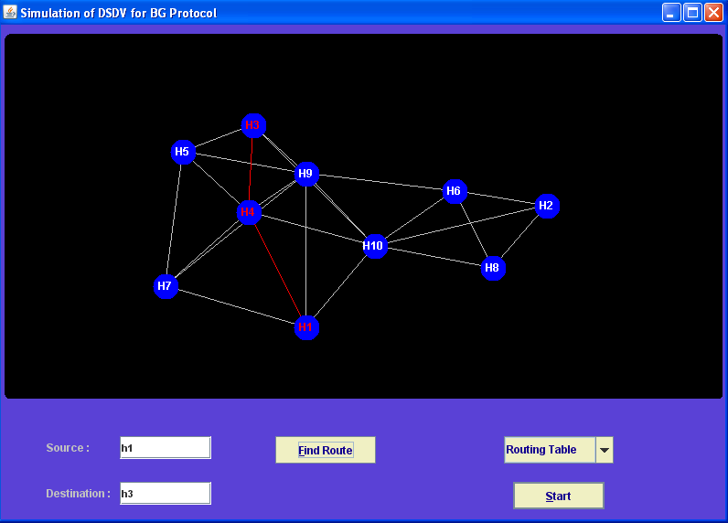
FIG 6.1.5 SCREEN SHOWING THE FEASIBLE PATH

6.1.6 SCREEN SHOWING NON EXISTENCE OF PATH

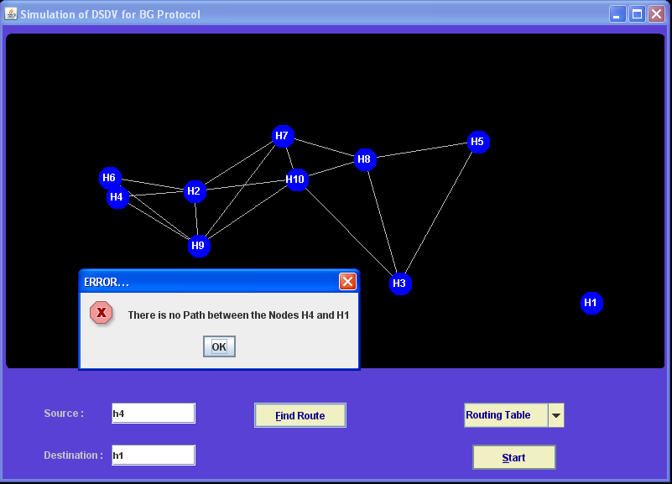
FIG 6.1.6 SCREEN SHOWING NON EXISTENCE OF PATH

    - SCREEN SHOWING THE ROUTING TABLE

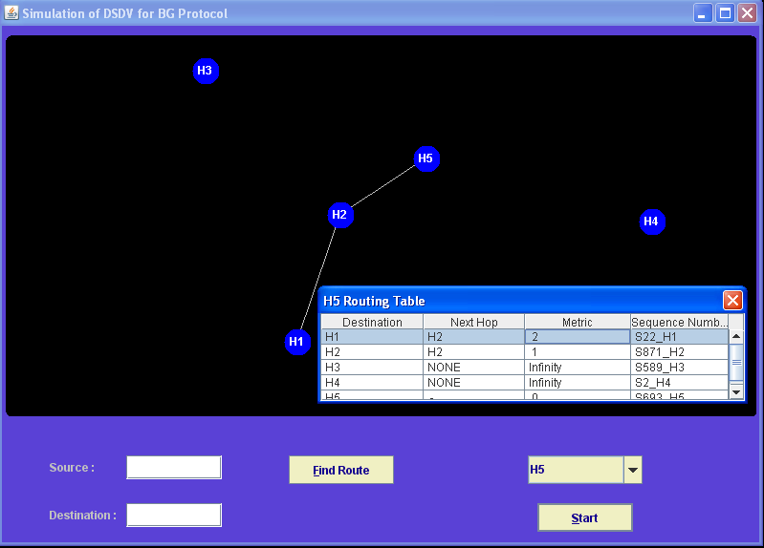
FIG 6.1.7 SCREEN SHOWING THE ROUTING TABLE

    - SCREEN SHOWING IMPROPER SOURCE OR DESTINATION

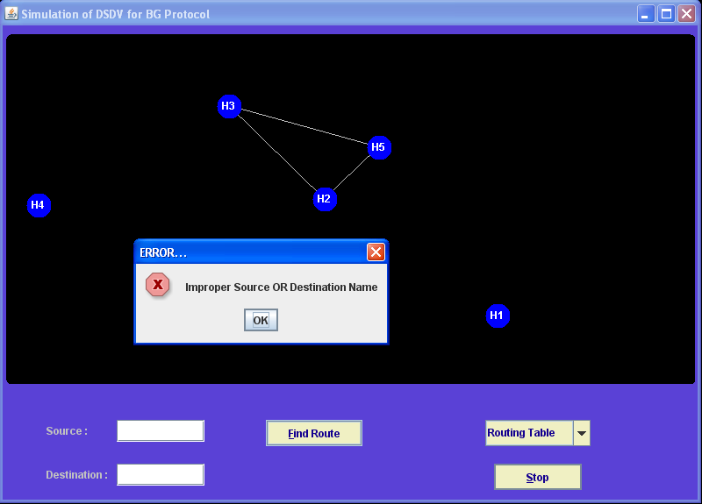
FIG 6.1.8 SCREEN SHOWING IMPROPER SOURCE OR DESTINATION

6.1.9 SCREEN SHOWING IMPROPER SOUREC OR DESTINATION

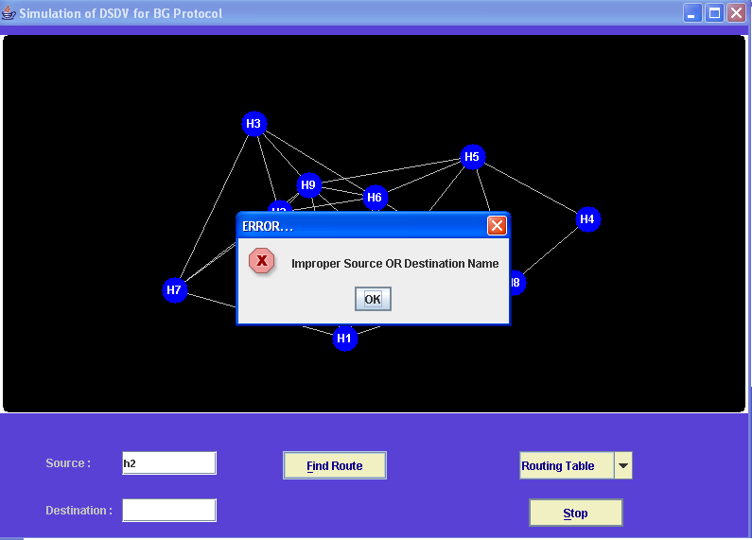
FIG 6.1.9 SCREEN SHOWING IMPROPER SOURCE OR DESTINATION

7. TESTING
7.1 INTRODUCTION

Testing is one of the most important phases in the software development activity. In software development life cycle (SDLC), the main aim of testing process is the quality; the developed software is tested against attaining the required functionality and performance.

During the testing process the software is worked with some particular test cases and the output of the test cases are analyzed whether the software is working according to the expectations or not.

The success of the testing process in determining the errors is mostly depends upon the test case criteria, for testing any software we need to have a description of the expected behaviour of the system and method of determining whether the observed behaviour confirmed to the expected behaviour.

7.2 LEVELS OF TESTING

Since the errors in the software can be injured at any stage. So, we have to carry out the testing process at different levels during the development. The basic levels of testing are Unit, Integration, System and Acceptance Testing.

The Unit Testing is carried out on coding. Here different modules are tested against the specifications produced during design for the modules. In case of integration testing different tested modules are combined into sub systems and tested in case of the system testing the full software is tested and in the next level of testing the system is tested with user requirement document prepared during SRS.

There are two basic approaches for testing. They are

7.2.1 FUNCTION TESTING

In Functional Testing test cases are decided solely on the basis of requirements of the program or module and the internals of the program or modules are not considered for selection of test cases. This is also called Black Box Testing

7.2.2 STRUCTURAL TESTING

In Structural Testing test cases are generated on actual code of the program or module to be tested. This is called White Box Testing.

7.3 TESTING PROCESS

A number of activities must be performed for testing software. Testing starts with test plan. Test plan identifies all testing related activities that need to be performed along with the schedule and guide lines for testing. The plan also specifies the levels of testing that need to be done, by identifying the different testing units. For each unit specified in the plan first the test cases and reports are produced. These reports are analyzed.

7.3.1 TEST PLAN

Test plan is a general document for entire project, which defines the scope, approach to be taken and the personal responsible for different activities of testing. The inputs for forming test plane are
Month plan
Requirements document
System design

7.3.2 TEST CASE SPECIFICATION

Although there is one test plan for entire month test cases have to be specified separately for each test case. Test case specification gives for each item to be tested. All test cases and outputs expected for those test cases.

7.4 TEST CASE EXECUTION AND ANALYSIS

The steps to be performed for executing the test cases are specified in separate document called test procedure specification. This document specify any specify requirements that exist for setting the test environment and describes the methods and formats for reporting the results of testing.

7.4.1 UNIT TESTING

Unit testing mainly focused first in the smallest and low level modules, proceeding one at a time. Bottom-up testing was performed on each module. As developing a driver program, that tests modules by developed or used. But for the purpose of testing, modules themselves were used as stubs, to print verification of the actions performed. After the lower level modules were tested, the modules that in the next higher level those make use of the lower modules were tested.

Each module was tested against required functionally and test cases were developed to test the boundary values.

7.4.2 INTEGRATION TESTING

Integration testing is a systematic technique for constructing the program structure, while at the same time conducting tests to uncover errors associated with interfacing. As the system consists of the number of modules the interfaces to be tested were between the edges of the two modules. The software tested under this was incremental bottom-up approach.

Bottom-up approach integration strategy was implemented with the following steps.

- Low level modules were combined into clusters that perform specific software sub functions.
- The clusters were then tested.

7.4.3 SYSTEM TESTING

System testing is a series of different tests whose primary purpose is to fully exercise the computer-based system. It also tests to find discrepancies between the system and its original objective, current specifications.

7.5 TEST CASES

Test. No. | Input | Expected Behavior | Observed  Behavior | Status  P =Passed  F = Failed
1 | Enter Number of Nodes and press OK. | Window with entered number of nodes has to appear. | Window with entered number of nodes appeared. | P
2 | If entered number of nodes is <2 | Window has to appear with message"Min nodes are two". | Window with message"Min nodes are two". | P
3 | If entered number of nodes is >16 | Window has to appear with message max nodes are sixteen. | Window with message max nodes are sixteen. | P
4 | If nothing is entered then | Window has to appear by taking default nodes as sixteen. | Window with sixteen nodes appeared. | P
5 | Enter source, destination nodes and click Find Route | A red color line showing the Shortest path from source to destination has to appear. | A red color line showing the Shortest path from source to destination . | P
6 | Enter source,  Destination nodes and click “Find Route” | If there is No path b/w from source to destination then message “No path b/w source and destination” has to appear. | Message “No path b/w source and destination” appeared. | P
7 | If either of the source or destination is not entered | Message “Improper source or destination “ has to appear | Message “Improper source or destination “ appeared. | P
8 | Select a node to find routing table | Routing Table has to appear showing Routing Table Information | Routing Table Appeared Showing the routing table information. | P
9  10 | Select Start to make the nodes moving  Select Stop to  make the  nodes stop  and link. | All the Nodes in the window has to move and link dynamically.  All the nodes in the window has to stop moving and link together. | Window showing the motion of the nodes appeared.  Window with stable nodes and links appeared. | P  P
TABLE 7.5.1 TEST CASES

8. CONCLUSION
We have proposed Destination Sequenced Distance Vector Using Border Gateway Protocol mainly deals with interdomain routing and enhances the performance of the Network in terms of both Internet size and Quality of the services it provides. BGP is a de facto standard routing protocol. It also deals with Traffic Engineering. Traffic Engineering covers the evaluation and the improvement of the performance of operational IP networks.
BGP contains a well-understood and widely-deployed mechanism for data distribution. DSDV helps in finding the shortest path from a source to destination node and reduces the overhead in the selection of paths for data communication. Interdomain routing system main rely on topology of the network. So, as the topologies of the network and path selection mechanisms are simple, the routing is simple. It can be extended to the existing and emerging topologies of network.DSDV Using Border Gateway Protocol can be implemented to control the flow of traffic and provides reliable data communication in the network.Traffic Engineering combined with BGP specifications would result in achieving the better performance of network.

BIBLIOGRAPHY
1) Highly Dynamic Destination Sequenced Distance Vector Routing DSDV for Mobile Computers By Charles E Perkins, IBM T J Watson Research Center Hawthorne NY

2) Securing the Destination-Sequenced Distance Vector Routing Protocol by Tao Wan Evangelos Kranakis, P.C. van Oorschot

3) Border Gateway Protocol, Part III by John Ioannidis

4) BGP, where are we now? By John Scudder and David Ward
IETF-68, March 22, 2007

5) BGP – A route too far by Michael Silvin, Fredrik Söderquist

6) BGP Stability Study http://psg.com/~avri/irtf/BGPstability-
charter.html

7) The Basics of BGP Routing and its Performance in Today’s Internet
Nina Taft, Sprint, Advanced Technology Labs, California, USA

8) A Survey of BGP Security by KEVIN BUTLER, Systems and Internet Infrastructure Laboratory Pennsylvania State University, TONI FARLEY
Arizona State University, PATRICK MCDANIEL Systems and Internet Infrastructure Laboratory Pennsylvania State University and JENNIFER REXFORD Princeton University

9) http://en.wikipedia.org/wiki/BGP

10) http://en.wikipedia.org/wiki/DSDV

11) The Complete Reference Java by Herbert Schildt
12) Thinking in Java by Bruce Eckel
13) J2SE API by Sun Microsystems
14) Software Engineering by pankaj Jalote
15) UML Diagrams by Grady Booch
16) www.sun.com/j2ee/mailapi
17) www.sun.com/j2se

LIST OF FIGURES

2.1.1 TOPOLOGY OF AN ISP NETWORK 10
2.2.1.1 INTERNAL AND EXTERNAL BGP SESSIONS 12
2.5.2.1 NODES IN A NETWORK 16
2.5.2.2 ROUTING TABLE OF NODE A 16
5.1.1 CLASS DIAGRAM 26
5.1.2 SEQUENCE DIAGRAM 27
5.1.3 COLLABORATION DIAGRAM 28
5.1.4 ACTIVITY DIAGRAM 29
6.1.1MAIN SCREEN 30
6.1.2 INPUT SCREEN 31
6.1.3 SCREEN SHOWING THE NODES 32
6.1.4 POSITION OF NODES AFTER SOMETIME 33
6.1.5 SCREEN SHOWING THE FEASIBLE PATH 34
6.1.6 SCREEN SHOWING NON EXISTENCE OF PATH 35
6.1.7 SCREEN SHOWING THE ROUTING TABLE 36
6.1.8 SCREEN SHOWING IMPROPER SOURCE OR DESTINATION 37
6.1.9 SCREEN SHOWING IMPROPER SOURCE OR DESTINATION 38

LIST OF TABLES

7.5.1 TEST CASES 44

